Additional Publications
CPG have many useful publications
https://www.cgpbooks.co.uk/primary-books/
In particular we would recommend the following:
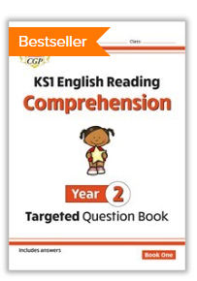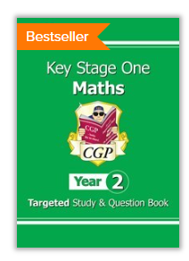

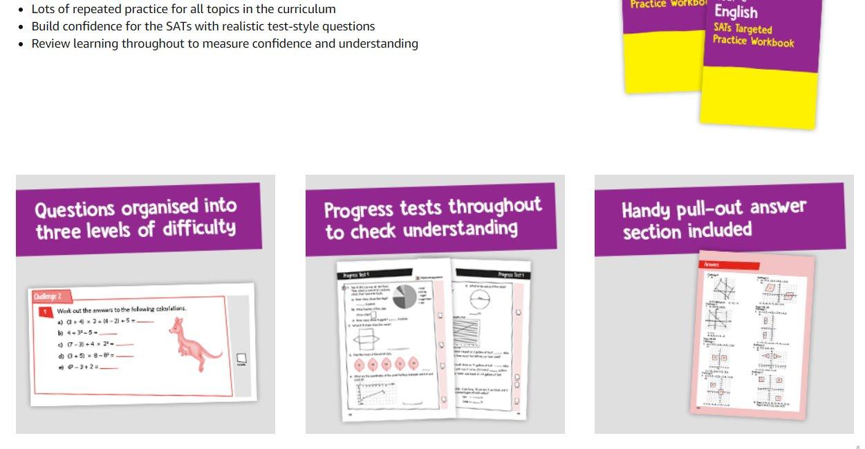
Collins have many useful publications, in particular the Collins books – targeted practice workbooks

